PURPOSE version: 2024-09
The objective of this form is to document the entity’s information system (IS) and communication relevant to the preparation of the financial statements. The engagement team can provide this template to the entity to complete. Alternatively, the engagement team may complete this document by making inquiries of relevant entity personnel and recording their responses below.
Information provided by:
 | Name | Title | Date
Entity’s representative: | Enes Hatibović | IT Manager | 12.05.2025
Entity’s representative: | Edin Ramić | System Administrator | 12.05.2025

- Organisation and systems overview

Entity Name: ASA Bolnica
Period end date: 12.05.2025
  - Main client contacts
Indicate the main contact(s) for this engagement (Accounting and IT):
Individual's name | Title | Email | Telephone | Comments
Enes Hatibovic | IT Manager | Enes.hatibovic@asabolnica.ba | 061447945
  - The IT function and IS Security function
Briefly describe IT department organisation structure or attach the IT function organisation chart.

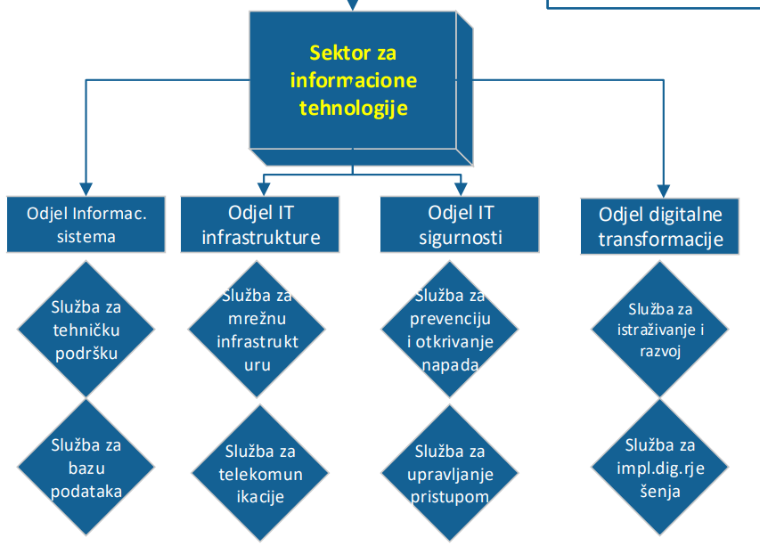

Complete the following table, or provide an organisation chart, if the entity has one of the following:
- A dedicated IT department with structured IT processes supported by personnel that have software development and IT environment maintenance skills, or
- Use of internal service providers (e.g., group shared resources) to manage IT processes within, the entity’s IT environment (e.g., third-party hosting).

Name of key IT personnel | Position/role | Group / department within the IT Department | IT function
Damir Spahić | Network Administrator |  | Cross function
Edin Ramić | System Admin |  | Cross function
Enes Hatibović | IT manager |  | Cross function
Anisa Kadrić | System Admin |  | Cross function
Timur Kuskunović | R&D |  | Cross function
  - Relevant IT suppliers or external service providers
We consider relevant IT suppliers where the entity is outsourcing the hosting of its IT environment to a third party or using a shared service centre for central management of IT processes.
Common services that may be outsourced include:
- Software development and maintenance
- Infrastructure maintenance (operating systems, network and security tools)
- Outsourcing of IT personnel
- Hardware purchase and maintenance
- Cloud services such as:
  - Infrastructure as a service (IaaS) - This is a type of cloud computing service where the service provider offers server and networking resources on demand while the entity manages the operating system and applications
  - Platform as a service (PaaS) – This is a cloud computing service where the service provider offers network, server and operating system resources while the entity manages only the applications.
  - Software as a service (SaaS) – This is a type of cloud computing service where the service provider offers network, server, operating system and applications resources on demand. It allows the entity to connect to and use cloud-based apps over the Internet.
Service provider name | Service description - (also indicate whether they follow the entity’s processes OR their own processes and whether a SOC report is available)
Dedalus | HCIS
Wizard Lab | LIS
BERG | RIS PACS
CloudIT | DMS
BBS | ERP
Kodeks | Licenses, IT infrastructure and IT security
Racional | Printing solution and printers
Tring | Fiscal printers
  - Network infrastructure and security
Briefly describe the entity’s IT network infrastructure or attach an infrastructure diagram.
The description and/or diagram includes elements such as:
- Use of cloud, web-facing application of a shared service centre
- Data centre location
- Remote access, including:
  - Whether key IT assets (e.g., applications, databases, folders or reports) are available through remote access and to whom they are available (e.g., internal users, clients, partners or everyone).
  - The name of the remote software in use
- Use of network management systems (e.g. Microsoft Active Directory, firewalls, Intrusion Detection Systems (IDS), Intrusion Prevention Systems (IPS) and/or other protection measures in place to protect the entity’s IT environment)

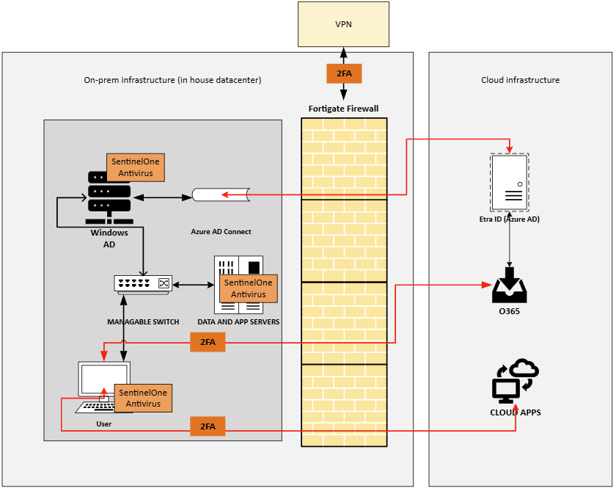
The organization’s IT infrastructure is based on a hybrid model combining on-premises servers and cloud services. The local infrastructure includes a Windows Active Directory environment hosted in the on-premises server room. This environment is hybrid-connected to Microsoft Entra ID (formerly Azure AD), with all users synchronized from the local AD to the cloud, where Microsoft 365 licenses are assigned and two-factor authentication (2FA) is enforced.
The on-premises location is protected by Fortinet FortiGate firewalls, which manage all inbound and outbound network traffic. VPN access is provided through Fortinet's VPN solution, also protected with 2FA, allowing authorized users to securely connect to internal resources remotely.
Antivirus and endpoint protection are managed centrally using SentinelOne, integrated with the Singularity Operations Center, which ensures real-time monitoring, threat detection, and response.
Remote access is further enabled for IT administrators via the N-able RMM system, which also requires 2FA and is exclusively accessible to designated IT administrators.
Network security is enforced through multiple layers, including:
- Microsoft Active Directory for centralized authentication and user management
- FortiGate firewalls for traffic filtering and VPN access
- SentinelOne for endpoint protection
- 2FA across all access points
- Strict role-based access and segmentation policies within the internal VLAN-based network
  - Significant changes in IT environment
Significant changes during the audited period | Brief description of change (or N/A)
Deployment of new financial/accounting applications  (If significant changes occurred in the period, complete 3.2.4) | N/A
Application end of life (i.e., planned end of application support, removal from use by the entity) | N/A
Major version(s) or upgrade(s) | N/A
Migration of data to a new system during the period | N/A
Significant IT projects undertaken by management that could affect the financial statements | N/A
Adoption of new technology that could affect the financial statements | BC is now fully connected with the BI system, enabling seamless data exchange and reporting.
Changes to service providers | N/A
[Enter any additional significant changes here] | N/A

Applications used by the entity
  - List of applications / systems / data warehouses relevant for processing and recording of financial information
For each business process / cycle, list in the table below the application(s) being used for processing and recording financial information.
Business process / cycle/ function | Application  (name of specific module if applicable / System / Data warehouse name / name of supplier) | Version | Implemented/ upgraded during the year? | How is the application hosted? (entity’s server, a third party or shared service centre in a group) | Operating System | Database (including version) | Single Sign On | Type of application software | Configurable settings?
ALL | Business Central | 25 | Yes | Company's server | Windows server | SQL Server 2022 | Yes | Customised off-the-shelf | Yes

- Automation and use of data
This section assists us to understand how data is entered into the system(s), the nature of the reports produced and if financial data is transferred between applications.
  - Data Flow Diagram of financial reporting applications
If available, please attach the organisation’s systems (applications) description, relevant interfaces, input, output and flow of data [replace example below]:
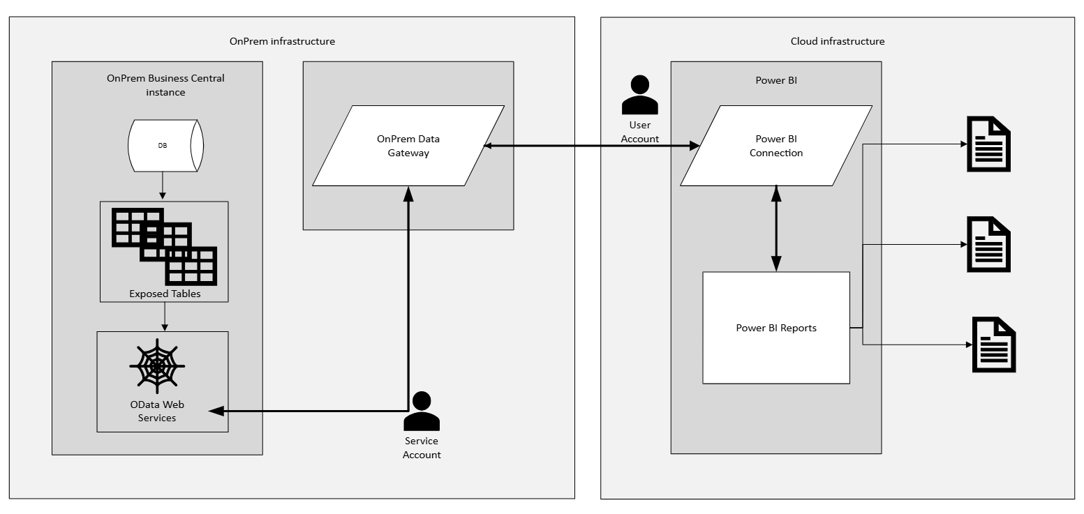

If a data flow diagram does not exist, record details on data flows, inputs, outputs, reports, etc. in the box below.

  - Main interfaces between applications that support the business processes / cycles (optional if 2.1 is completed)
- List all key interfaces between applications (i.e., those with a significant impact on the entity’s business processes and financial reporting). These include both interfaces within the entity and interfaces with external parties (e.g., Electronic Data Interchange (EDI), etc.).
- Provide details about each interface, such as the following:
1) fully automated, semi-automated or manual interface
2) nature of the data being transferred
3) if not fully automated, steps in place to perform the data transfer
4) controls to guarantee timely, accurate and complete data transfer (e.g. log review, exception reports, manual reconciliations, batch monitoring, etc.).

Interface applications | Details on the interface | Frequency (Batch, Real-time)
Business central to Dedalus HCIS | HL7 / API | Real-time
RIS to Dedalus HCIS | HL7 / API | Real-time
LIS to Dedalus HCIS | HL7 / API | Real-time
  - Describe the use of complex technology components (for example blockchain, robotic processing automation (RPA), artificial intelligence, etc.), if any.
- Description of IT processes
  - Manage Access

3.1.1. Manage Access process
Briefly describe the manage access process and which organisation units are involved with respect to:
  - Operating system software
  - Network access
  - IT applications access and
  - Database access
If available mention existing internal procedures or attach a copy of the relevant procedure or reference it below.

- Operating System Software
The HR department submits a request for creating a new user account, including all necessary user details, to the IT department via the UserManagement system. The IT team creates the user account in the Windows Active Directory (AD) and, based on the department the user belongs to, assigns access to the required systems and applications. Login credentials with a temporary password are provided to the new user's manager. Upon first login, the user is required to change the password.
- Network Access
The network is segmented into multiple VLANs, including those for medical staff, medical equipment, printers, administrative personnel, guests, servers, IP television, IT, executive management, and finance. A least privilege model is enforced between VLANs, permitting only essential traffic while all other communication is explicitly denied by default. All switches are managed, and each port is activated or deactivated as needed. Wi-Fi access for employees is controlled via a RADIUS server. VPN access is granted only to selected users upon manager approval and is implemented by the IT department. All network traffic is monitored through the firewall system.
- IT Applications Access
Access and permission levels to IT applications are granted by the IT department based on the employee’s job description or a request submitted by the immediate supervisor. All applications are integrated with the LDAP service, allowing users to access all systems and applications using a single user account. Two-factor authentication (2FA) is mandatory for all users.
- Database Access
Direct access to databases is granted only to applications via service accounts. Data exchange between applications, or between the database and end users, is handled through an integration server or web services. When using web services, access is indirect — the data gateway connects to the database using a service account, while the user accesses the gateway with their own credentials. Only approved users are authorized to access the data gateway using their credentials.

3.1.2. User accounts administration
- Describe Administrators accounts for applications identified within the form that are accessible by single individuals
- Describe if Administrator roles are defined
- Describe how user rights are set up (assigned individually, roles based on function etc.)
- Describe the segregation of duties implemented by the entity via user rights
- Describe the method by which user accounts authenticate to the relevant applications / systems.

User Accounts Administration
Each IT administrator has a separate domain account with administrative privileges, which is used only when elevated access is required. For daily tasks, administrators use their standard user accounts. On client computers, Local Administrator Password Solution (LAPS) is implemented for secure and controlled local administration.
Administrator roles are clearly defined and include: system administrator, network administrator, cloud applications administrator, and infrastructure administrator. User rights are primarily assigned based on role-based access control (RBAC), ensuring that access corresponds to the employee’s job function.
Any access requests that fall outside of predefined roles are processed only upon formal request from the HR department or the user's direct supervisor.
Authentication is managed through LDAP / Active Directory, with single sign-on (SSO) enabled across systems. Two-factor authentication (2FA) is mandatory, and service accounts are strictly separated from user accounts to ensure security and accountability.

3.1.3 Authentication method to access IT resources
Describe authentication methods and password policy as they apply to applications, operating systems and databases.
Application/ operating system/ databases | Password strength (document parameters or provide a screenshot of the settings) | Two factor  authentication  (i.e., token, SMS, other) (Y/N) | Describe two factor authentication (if applicable)
Windows AD | Screenshot provided (password policy) | Yes | Token
O365 | On prem synced | Yes | Sms or authenticator app
HCIS | SSO (Windows AD LDAP) | Yes | Token
LIS | SSO (Windows AD LDAP) | Yes | Token
RIS | SSO (Windows AD LDAP) | Yes | Token
Business central | SSO (Windows AD LDAP) | Yes | Token

  - Manage Change
Describe how the entity manages its IT application, database and operating system changes, if applicable. Such changes may be programmed in-house, performed by an IT consultant / external party, or processed by a software supplier.

3.2.1 Describe how IT application, database and operating system change requests are submitted, evidenced, approved by responsible personnel and tested prior to implementation. Also describe segregation of duties within the Manage Change process.
Document provided. (Promjena u ERPu.pdf)

3.2.2 Describe the use of separate IT environments for development, testing and production
Each of our applications operates within three separate environments: development, testing, and production.
Development is used for coding, configuration, and implementing new features.
Testing serves to validate functionality and stability before deployment.
Production is the live environment used by end users and contains only fully tested and approved versions.

3.2.3 Regulatory or accounting changes impacting IT systems
Describe changes that occurred during the period being audited relating to regulatory or accounting changes.
No changes

3.2.4 Implementation of a new system relevant to financial reporting (see section 1.5 above)
Describe changes that occurred during the period being audited relating to implementation of new systems relevant to financial reporting. Describe the project phases and its current status, the date the entity started to use the new application and the data migration process.
No changes

  - IT Operations (Data processing)
Describe how financial data is managed and processed by the IT Department through batch processing / job scheduling, including segregation of duties in the IT operations process (e.g., accuracy and completeness reports, error-handling controls, etc.).
Job scheduling is used for Power BI automation.

  - Other relevant IT processes
Describe other IT processes, including data backup, continuity procedures and data centre physical security.

3.4.1 Data backups and IT continuity
Describe the process of creating a copy of the financial data to protect against accidental or malicious deletion, corruption, hardware failure, ransomware attacks, and other types of data loss.
Document provided. (Politika bekapa.pdf)

3.4.2 Physical security processes around data centres
Describe the physical security processes applied to protect IT resources (e.g., hardware, software, network, and data) from natural disasters, burglary, theft, terrorism, and other events that could cause damage or loss to the entity’s financial data.
Document provided. (Procedula fizicke sigurnosti IT resursa.pdf)

  - Security events and processes

3.5.1 Security vulnerability management process
Describe your vulnerability management process using either internal or external parties (e.g.: asset inventory, vulnerability scan, vulnerability classification, patching and other remediation actions).
Document provided.

3.5.2 Cyber attacks / incidents
Identify and list cyber attacks or incidents which may have compromised data, transactions or generated losses to the entity.
Describe briefly the root cause of the incident / problem and the entity’s response.
Incidents / problems | Applicable? | Description, root cause and impact
Cyber attack | No | N/A
System disruption | No | N/A
Data loss | No | N/A
Delay in data processing / automated report preparation | No | N/A
Slow application change management | No | N/A
Problems during application data migration | No | N/A
Known application functionality gaps – manual workaround needed | No | N/A
Other | No | N/A

System and Organisation Controls (SOC) reporting

